4 A.Conduct task analysis for an app and document user flows. Create corresponding wireframes using Lucidchart.
🎯 AIM
To analyze user tasks in an online shopping application, document user flows, and create corresponding wireframes using Lucidchart.

📘 INTRODUCTION
Task analysis is the process of identifying and understanding the steps a user takes to complete a specific goal in an application. User flow diagrams visually represent these steps, helping designers improve usability and navigation. Lucidchart is a diagramming tool used to create flowcharts and wireframes efficiently.

🧩 TASK IDENTIFICATION
The following key tasks in an online shopping app are identified:
- Browsing products
- Searching for a product
- Adding products to cart
- Checkout process

🔄 USER FLOW DIAGRAM (COMBINED FLOW)
Master Flow:
Start → Open App → Login/Register → Home Screen →
Browse/Search → Product List → Product Details →
Add to Cart → Cart → Checkout →
Enter Shipping Details → Payment → Place Order → End
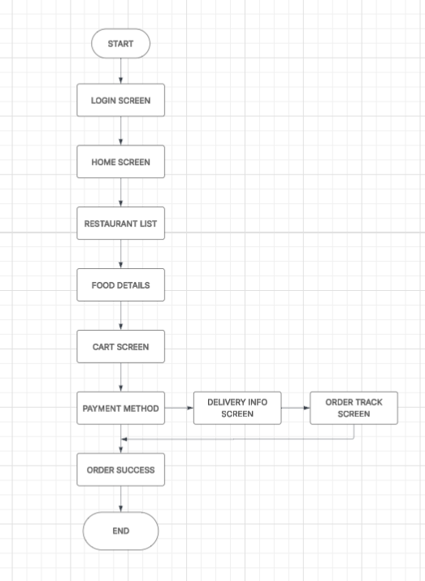

🔍 DETAILED TASK ANALYSIS
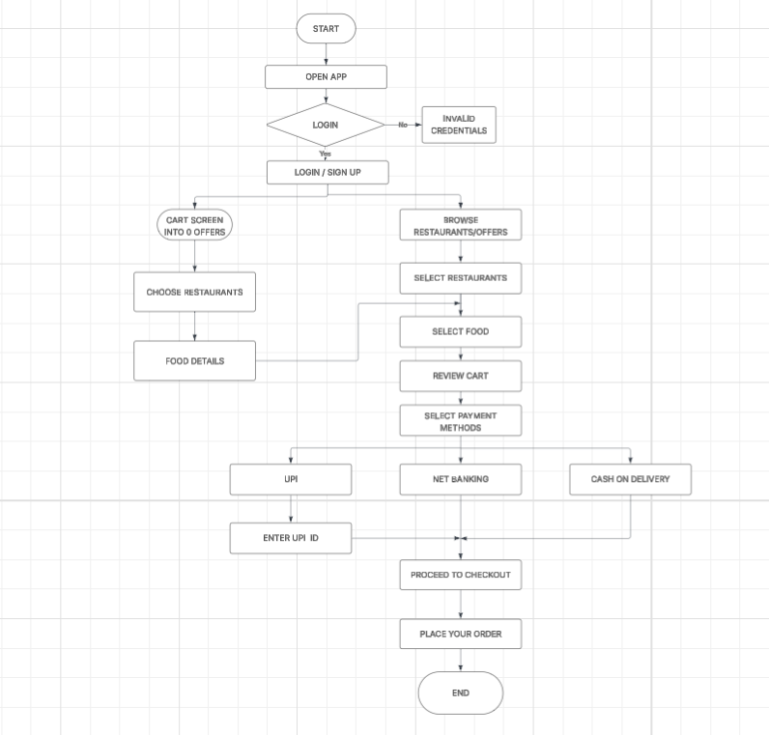
1️⃣ Browsing Products
- User opens home screen
- Selects category
- Views product list
- Clicks product
- Views product details
Flow:
Home → Categories → Product List → Product Details

2️⃣ Searching for a Product
- User taps search bar
- Enters keyword
- Views results
- Selects product
Flow:
Search → Enter Query → Results → Product Details

3️⃣ Adding Product to Cart
- User views product
- Selects options (size, quantity)
- Clicks "Add to Cart"
Flow:
Product Details → Select Options → Add to Cart

4️⃣ Checkout Process
- User opens cart
- Reviews items
- Proceeds to checkout
- Enters shipping details
- Enters payment details
- Places order
Flow:
Cart → Review → Checkout → Shipping → Payment → Place Order

🔷 DECISION POINTS
- Is user logged in?
- Is product available?
- Continue shopping or checkout?
- Is payment successful?

🧱 WIREFRAME DESIGN
📱 Home Screen
- Search bar
- Categories
- Featured products

📱 Product List Screen
- Product grid
- Filters and sorting options

📱 Product Details Screen
- Product image
- Description
- Price
- Add to Cart button

📱 Cart Screen
- List of selected items
- Quantity controls
- Total price
- Checkout button

📱 Checkout Screen
- Shipping address form
- Payment options
- Place order button

📱 Order Confirmation Screen
- Order success message
- Order details

⚙️ PROCEDURE (USING LUCIDCHART)
- Open Lucidchart and create a new document
- Select a blank template
- Add shapes:
  - Oval → Start/End
  - Rectangle → Process
  - Diamond → Decision
- Label each step clearly
- Connect shapes using arrows
- Organize flows logically
- Add colors for clarity
- Save and export the diagram

📊 RESULT
The user flow diagram and wireframes for the online shopping application were successfully created using Lucidchart. The flow clearly represents all major user tasks and navigation paths.

🧾 CONCLUSION
- Task analysis helps in understanding user behavior
- User flows improve navigation design
- Wireframes provide a visual structure of the application
- Lucidchart is effective for creating structured diagrams
PROJECT LINKS:
TASK ANALYSIS:
https://lucid.app/lucidchart/ea62defa-77bf-43e9-ac0c-0f46eb1e13ee/edit?viewport_loc=-1568%2C-400%2C4053%2C2123%2C0_0&invitationId=inv_b1b2d972-b89c-4796-aaa3-a2173138e669

USER FLOW:
https://lucid.app/lucidchart/a4511a21-5c62-4f32-8e4b-da369f55ddf2/edit?viewport_loc=-821%2C-35%2C3454%2C1809%2C0_0&invitationId=inv_6dffb30b-afef-4b8f-b128-e6d8f8bd6f4b

